**Lab Report-03**



**Gandaki College of Engineering and Science**

***Distributed System***

***Lab Experiment: Java RMI Implementation***

Submitted By:

Name: Dipendra Raut Kurmi

Roll.No: 18

Batch: 2021SE

Submitted To:

Er. Amrit Poudel

Lecturer at Gandaki College Of

Engineering and Science

**Objective:**

To implement remote method invocation between a client and server using ava RMI.

**Theory:**

Java RMI (Remote Method Invocation) allows an object residing in one Java Virtual Machine (JVM) to invoke methods on an object located in another JVM. It provides a simple and effective way for developing distributed applications in Java.

**Features of Java RMI:**

* Provides distributed object communication.
* Supports remote object invocation.
* Allows passing of complex objects between JVMs.
* Built-in Java security manager.
* Uses Java serialization.

### **Code:**

// RMI Interface (Hello.java)

import java.rmi.Remote;

import java.rmi.RemoteException;

public interface Hello extends Remote {

String sayHello() throws RemoteException;

}

// RMI Server Implementation (HelloImpl.java)

import java.rmi.RemoteException;

import java.rmi.server.UnicastRemoteObject;

public class HelloImpl extends UnicastRemoteObject implements Hello {

protected HelloImpl() throws RemoteException {

super();

}

public String sayHello() throws RemoteException {

return "Hello, this is a remote method call!";

}

}

// Server Program (Server.java)

import java.rmi.registry.LocateRegistry;

import java.rmi.registry.Registry;

public class Server {

public static void main(String[] args) {

try {

HelloImpl obj = new HelloImpl();

Registry registry = LocateRegistry.getRegistry();

registry.rebind("Hello", obj);

System.out.println("Server is ready...");

} catch (Exception e) {

System.err.println("Server exception: " + e.toString());

e.printStackTrace();

}

}

}

// Client Program (Client.java)

import java.rmi.registry.LocateRegistry;

import java.rmi.registry.Registry;

public class Client {

public static void main(String[] args) {

try {

Registry registry = LocateRegistry.getRegistry("localhost", 1099);

Hello stub = (Hello) registry.lookup("Hello");

String response = stub.sayHello();

System.out.println("Response from server: " + response);

} catch (Exception e) {

System.err.println("Client exception: " + e.toString());

e.printStackTrace();

}

}

}

### **Result:**

When running the Server.java and Client.java programs:

1. The server starts and binds the remote object.
2. The client looks up the remote object and invokes the sayHello() method.
3. The server returns a greeting message.
4. The client receives and displays the response.

**Server Output:**

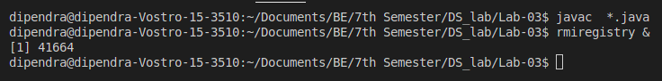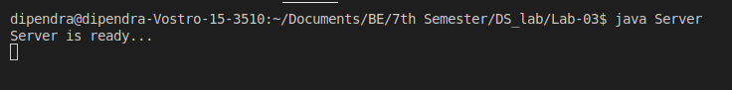

**Client Output:**

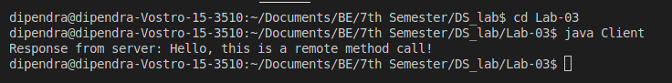

### **Conclusion:**

Hence, we successfully implemented remote method invocation between a client and server using Java RMI. This lab helped us understand distributed object communication and how RMI enables simple and secure interaction between Java programs across different JVMs.